**Setting Up Voice Over IP To Call Internally and Externally**

**By: Austin Tran-Struthers**

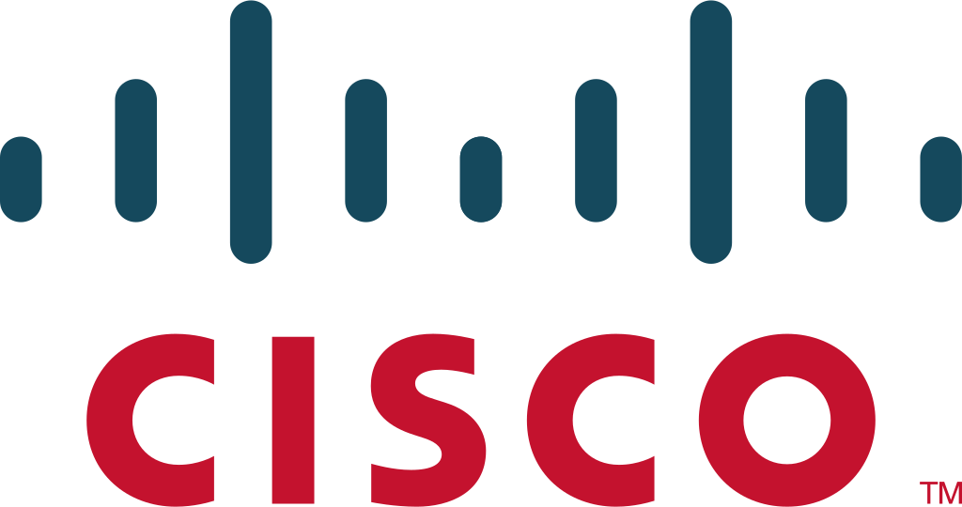

**Purpose**

To learn how to configure internal and external calling over voice over internet protocol using Cisco Call Manager Express to manage voice and data through the network.

**Background**

Voice over Internet Protocol (VoIP) is a technology that allows for the transmission of voice and multimedia communications over the internet. The first ideas for VoIP emerged in the 1970s, but the technology did not become widely available until the late 1990s and early 2000s.

VoIP works by converting analog audio signals, such as those from a telephone, into digital data packets. These packets are then sent over the internet to their destination, where they are converted back into analog signals for the recipient to hear. This allows for voice communication to take place over the internet, rather than over traditional telephone networks.

There are several different protocols used for VoIP, including SIP, H.323, and IAX. These protocols define the rules for how the digital data packets are transmitted and received. Additionally, VoIP systems can be either hardware-based or software-based, and can be used on a variety of devices, including smartphones, computers, and traditional telephones.

**Lab summary**

We had 2 Cisco 7960 phones which could call internally with 4 digit phone numbers and call externally but with limited physical range due to the limited dial plan we had.

**Lab Commands**

**option 150 [router ip address]** is used to specify the IP address of the TFTP server specifically used for VOIP, in order to have the phone obtain the correct firmware and configuration file.

**network[ ip address][ wildcard mask]** is utilized to specify the range of addresses that can be leased by the DHCP server.

**dial-peer voice [voice number] pots** enables the device to communicate to external or multiple other Cisco CME routers and create a connection between them.

**destination-pattern [pattern number]** specifies the numbers that the user may dial, adding a range will disable the user from picking numbers outside that range.

**forward-digits all** dictates how many digits the router will forward to the dial peer

**telephony-service** enables telephony and allows configuration

**ip source-address [ip address] port [port number]** assigns the IP address and port number used for registering and configuring IP phones

**create cnf-files** creates the files that the phone needs to be able to configure itself

**ephone-dn** creates a virtual port on the CME system that allows for multiple calls depending on how many ports are defined and allows for it to be configured.

**number 1921** assigns a number to the phone.

**ephone** allows configuration of the phone connected to the router

**mac-address** defines the mac address of the phone connected

**type 7960** specifies what model of ip phone is connected

**button** correlates the phone with a specific button number

**Network:**

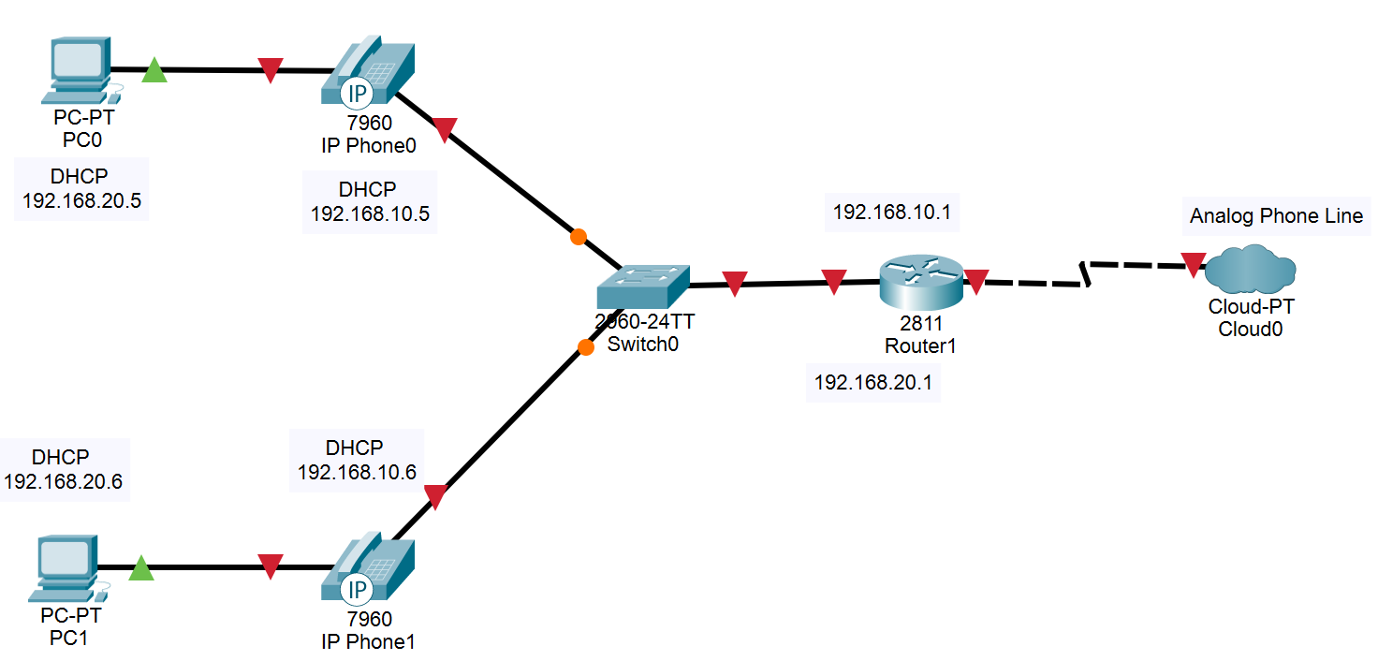  
**Configurations:**

**Router Config:**

version 12.4

service timestamps debug datetime msec

service timestamps log datetime msec

no service password-encryption

hostname R1

boot-start-marker

boot-end-marker

no aaa new-model

resource policy

memory-size iomem 10

no network-clock-participate slot 1

ip subnet-zero

ip cef

no ip dhcp use vrf connected

ip dhcp excluded-address 192.168.10.1 192.168.10.5

ip dhcp excluded-address 192.168.20.1 192.168.20.5

ip dhcp pool voip

network 192.168.20.0 255.255.255.0

default-router 192.168.20.1

option 150 ip 192.168.20.1

voice-card 0

no dspfarm

voice-card 1

no dspfarm

interface FastEthernet0/0

no ip address

shutdown

duplex auto

speed auto

interface FastEthernet0/1

no ip address

duplex auto

speed auto

interface FastEthernet0/1.10

encapsulation dot1Q 10

ip address 192.168.10.1 255.255.255.0

no snmp trap link-status

interface FastEthernet0/1.20

encapsulation dot1Q 20

ip address 192.168.20.1 255.255.255.0

no snmp trap link-status

interface FastEthernet0/1.30

encapsulation dot1Q 30 native

no snmp trap link-status

interface FastEthernet0/1/0

interface FastEthernet0/1/1

interface FastEthernet0/1/2

interface FastEthernet0/1/3

interface FastEthernet0/1/4

interface FastEthernet0/1/5

interface FastEthernet0/1/6

interface FastEthernet0/1/7

interface FastEthernet0/1/8

interface Serial0/2/0

no ip address

shutdown

interface Vlan1

no ip address

ip classless

ip http server

no ip http secure-server

control-plane

voice-port 0/3/0

voice-port 0/3/1

voice-port 0/3/2

voice-port 0/3/3

voice-port 1/0/0

voice-port 1/0/1

dial-peer voice 99 pots

destination-pattern 91[2-9].........

port 0/3/3

forward-digits all

telephony-service

max-ephones 2

max-dn 3

ip source-address 192.168.20.1 port 2000

system message if you can read this the phone is working

create cnf-files version-stamp Jan 01 2002 00:00:00

max-conferences 8 gain -6

ephone-dn 1

number 1921

ephone-dn 2

number 1922

ephone 1

mac-address 0015.2B47.6685

type 7960

button 1:1

ephone 2

mac-address 0015.62B5.E72C

type 7960

button 1:2

line con 0

line aux 0

line vty 0 4

login

scheduler allocate 20000 1000

end

**Switch Config:**

version 12.2

no service pad

service timestamps debug uptime

service timestamps log uptime

no service password-encryption

hostname the_switch

no aaa new-model

vtp domain CCNP

vtp mode transparent

ip subnet-zero

no ip domain-lookup

no file verify auto

spanning-tree mode pvst

spanning-tree extend system-id

vlan internal allocation policy ascending

vlan 10

name Data

vlan 20

name Voice

vlan 30

name Native

vlan 40

name MISC

vlan 50

name NATIVE

vlan 99

name MANAGEMENT

interface FastEthernet0/1

switchport trunk encapsulation dot1q

switchport trunk native vlan 30

switchport mode trunk

interface FastEthernet0/2

switchport access vlan 10

switchport mode access

switchport voice vlan 20

mls qos trust cos

spanning-tree portfast

interface FastEthernet0/3

switchport access vlan 10

switchport mode access

switchport voice vlan 20

mls qos trust cos

spanning-tree portfast

interface FastEthernet0/4

interface FastEthernet0/5

interface FastEthernet0/6

interface FastEthernet0/7

interface FastEthernet0/8

interface FastEthernet0/9

interface FastEthernet0/10

interface FastEthernet0/11

interface FastEthernet0/12

interface FastEthernet0/13

interface FastEthernet0/14

interface FastEthernet0/15

interface FastEthernet0/16

interface FastEthernet0/17

interface FastEthernet0/18

interface FastEthernet0/19

interface FastEthernet0/20

interface FastEthernet0/21

interface FastEthernet0/22

interface FastEthernet0/23

interface FastEthernet0/24

interface GigabitEthernet0/1

interface GigabitEthernet0/2

interface Vlan1

no ip address

shutdown

ip classless

ip http server

control-plane

line con 0

line vty 0 4

no login

line vty 5 15

no login

end

**Screenshots**

A ping to the router from PC1 to test connectivity through the phone to the router.

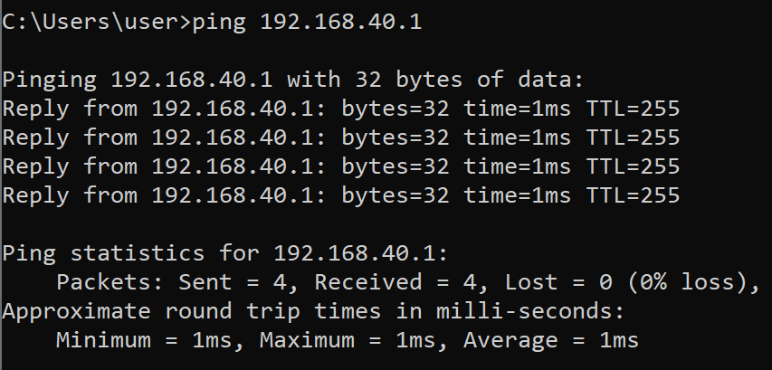

A ping from PC1 to PC2 to test connectivity across the network.

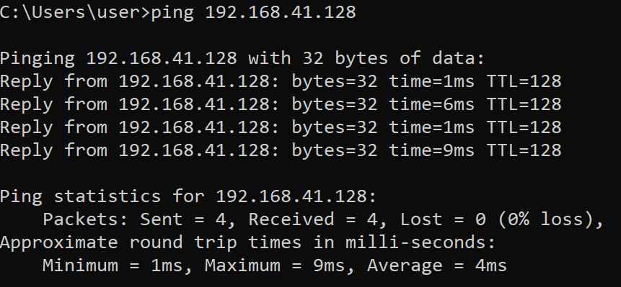

A phone that has been fully configured with an internal number.

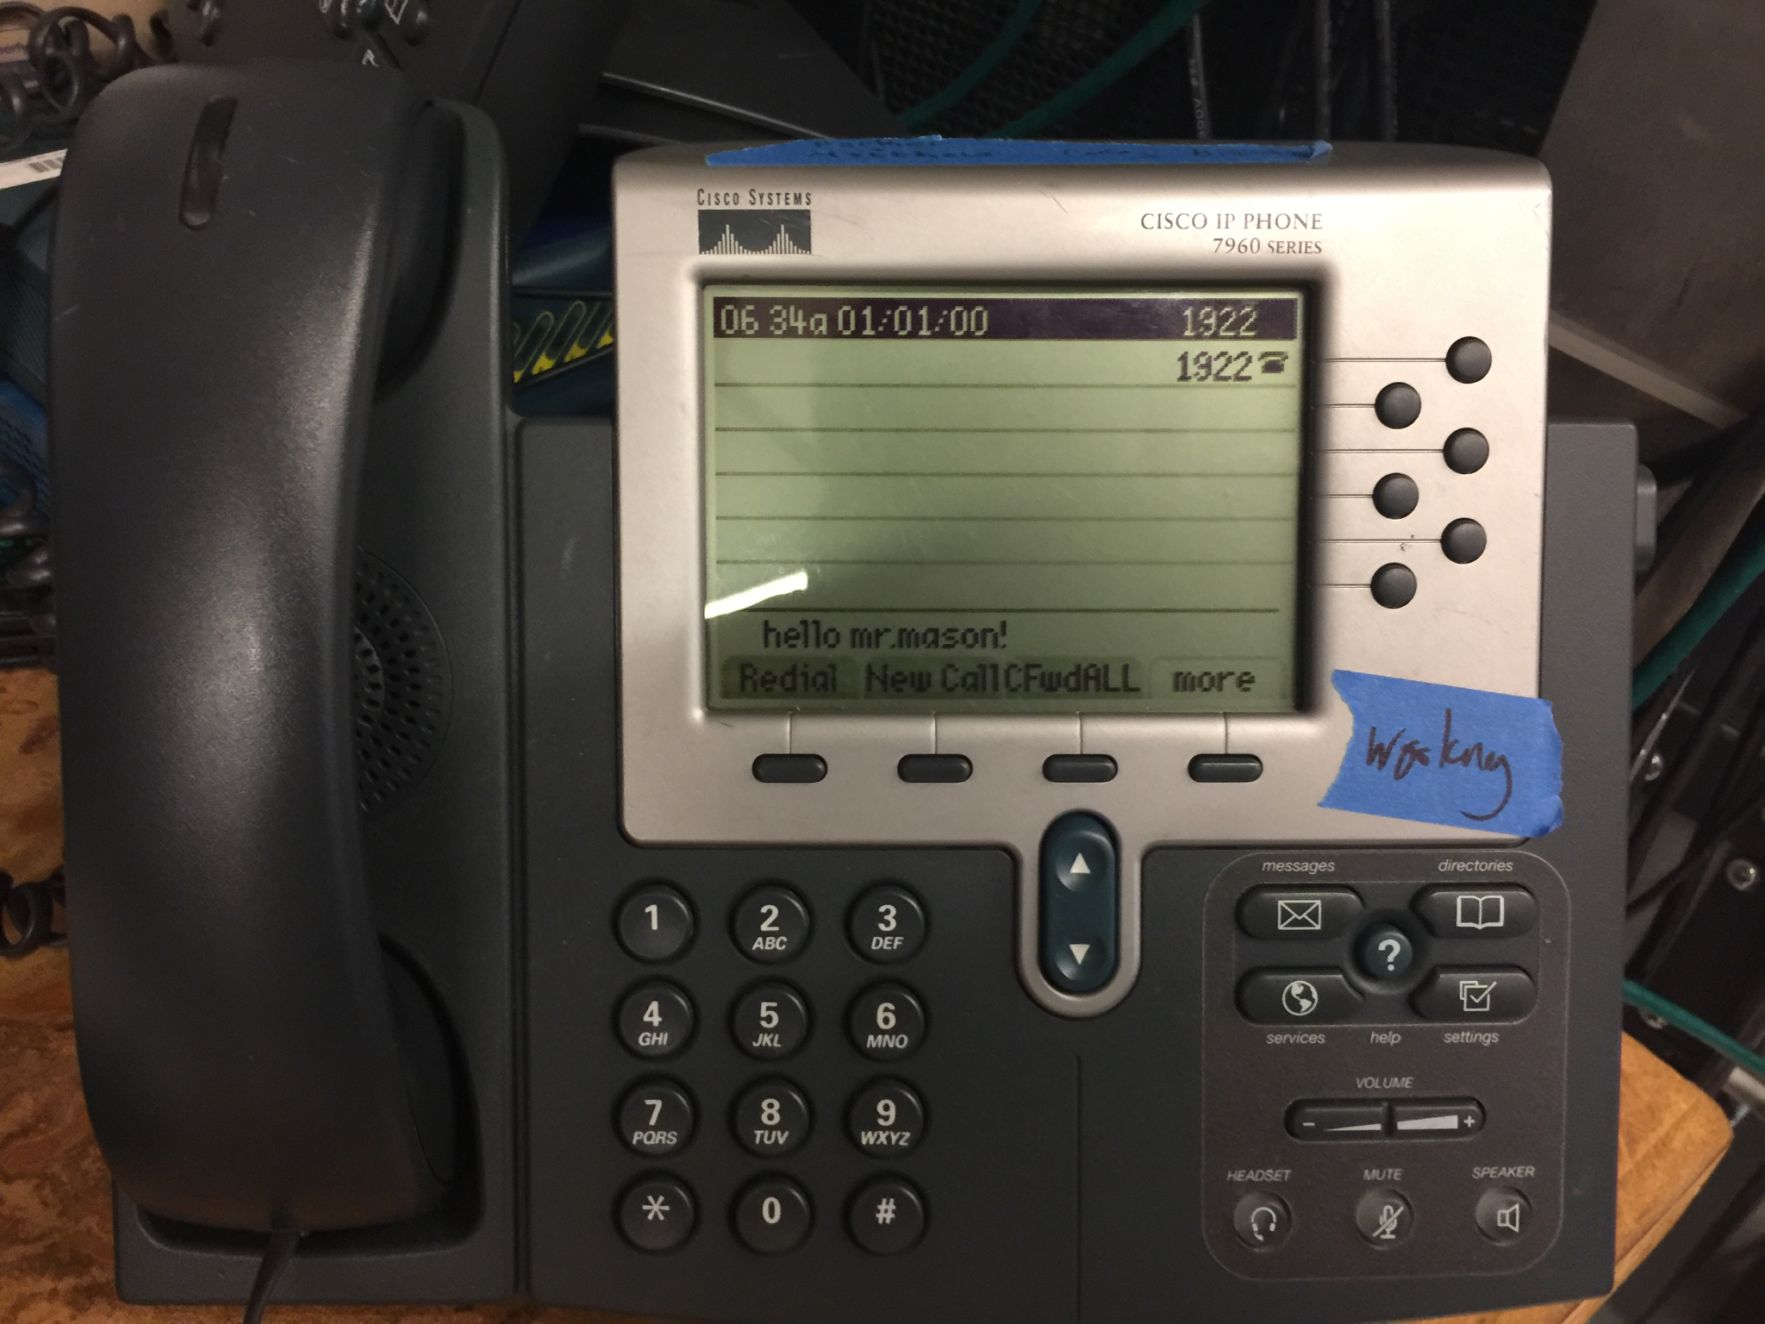

**Problems**

In the beginning we were having trouble with CME but then we realized a little bit later that it was not installed on there routers that we were using. Another problem that we had was that only about 4 out of the around 20 worked so that was a big bottleneck. Also, the whole process was very confusing as there were a lot of commands that we researched which were not required for the lab that we did.

**Conclusion**

Altogether I learned about how Cisco CME works and how to use voice over ip in this specific scenario with the 2 ip phones along with using vlans to separate traffic. I also learned how complicated configuring voice networks is.